

Update _2_0_3

Clinical Reminders

TBI Screening Update

Install Guide

November 2015

Product Development
Office of Information Technology
Department of Veterans Affairs

Table of Contents
Introduction 1
Install Details 3
Post Install 25

Introduction

UPDATE_2_0_3 contains 1 Reminder Exchange entry: UPDATE_2_0_3 TBI Screening. This entry contains the following reminder components:

- VA-TBI Screening (Reminder definition)
- VA-TBI Screening (Reminder dialog)
- VA-ADNS WHY NOTIFY (E) (Reminder dialog element)

VA-TBI Screening (Reminder definition)
- Update to description
- Update to the websites

VA-TBI Screening (Reminder Dialog)

- Changed the wording of the choice “Complete Screening for TBI Completed at another VA” to “No. TBI Screening completed at another VA since most recent deployment”
Prior version
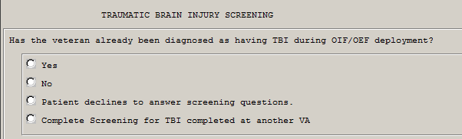
Revised
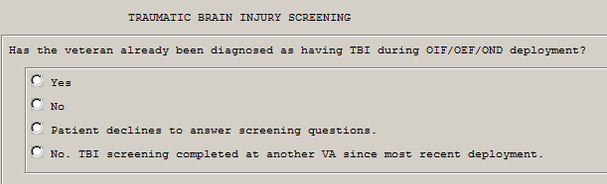
- Removed broken links

Prior version Revised
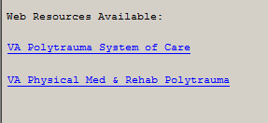
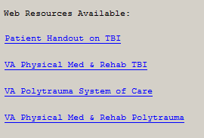

- Modified content of “screening completed at another VA…”
Prior version
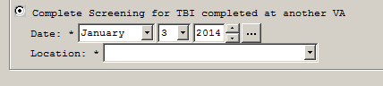
Revised
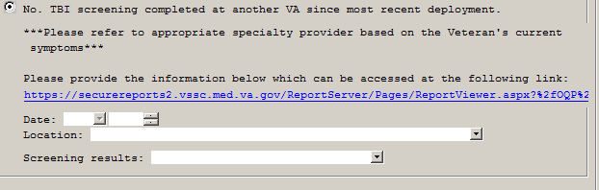
Web link takes user to the the TBI report history
Location list now VA sites only. Added section to describe previous screening results
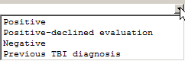
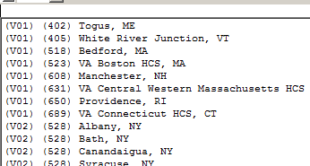

VA-ADNS WHY NOTIFY (E) (Reminder dialog element)

A site reported that two hyperlinks in the VA-ADVANCE DIRECTIVE NOTIFICATION AND SCREENING reminder dialog are no longer working. The hyperlinks are contained in TIU TEMPLATE FIELDs “VA-ETHICS-FORM 10-0137A” and “VA-ETHICS-FORM 10-0137B” and are part of the dialog text in dialog elements “VA-ADNS WHY NOTIFY (E)” and “VA-ADNS HOW NOTIFY (E)”. These two hyperlinks reference VHA FORM 10-0137A and 10-1037B. The two broken hyperlinks are:
http://vaww.va.gov/vaforms/medical/pdf/vha-10-0137A-fill.pdf
http://vaww.va.gov/vaforms/medical/pdf/vha-10-0137B-fill.pdf

After the reminder exchange UPDATE install, the new hyperlinks will be:
http://vaww.va.gov/vaforms/medical/pdf/vha-10-0137A.pdf
http://vaww.va.gov/vaforms/medical/pdf/vha-10-0137B.pdf

In the reminder exchange entry, we will only be sending out an updated element “VA-ADNS WHY NOTIFY (E)”. This will also repair the hyperlinks in “VA-ADNS HOW NOTIFY (E)”.

When installing the exchange entry is prompted for an ACTION, you should use OVERWRITE. This will be part of the overall INSTALL of the reminder exchange entry for this UPDATE. Please see install example. CPRS must be restarted for the changes to take place.

Install Details

This update is being distributed as a web host file. The address for the host file is: http://vista.med.va.gov/reminders/UPDATE_2_0_3.PRD

The file will be installed using Reminder Exchange, programmer access is not required
Installation:
=============
This update can be loaded with users on the system. Installation
will take five to ten minutes.

Note that during installation you could possibly see errors in your error trap due to clinical reminders being evaluated as it is being installed.

Prior to install

Print or save the reminder definition VA-TBI Screening for comparison after installation

Review finding item on the below elements: VA-TBI OI CONSULT FOR KNOWN TBI, and VA-PDIQ POLYTRAUMA CONSULT ELEMENT for comparison after installation

Install Example

To Load the Web Host File. Navigate to Reminder exchange in Vista

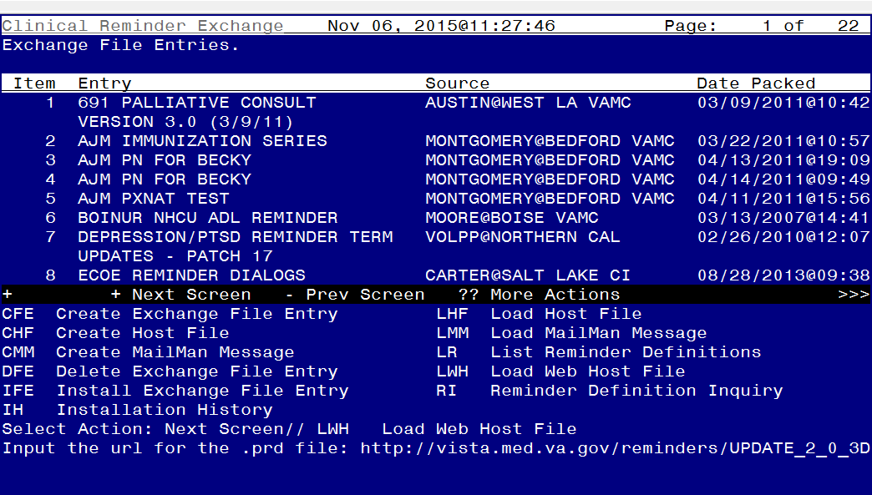

At the Select Action: prompt, enter LWH for Load Web Host File
At the Input the url for the .prd file: prompt, type the following web address:
http://vista.med.va.gov/reminders/UPDATE_2_0_3.PRD

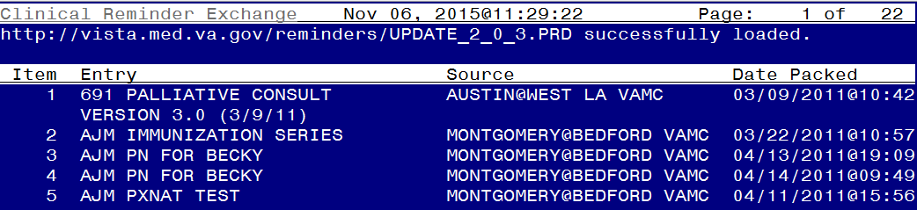
You should see a message at the top of your screen that the file successfully loaded.

Search and locate an entry titled UPDATE_2_0_3_2 TBI SCREENING in reminder exchange
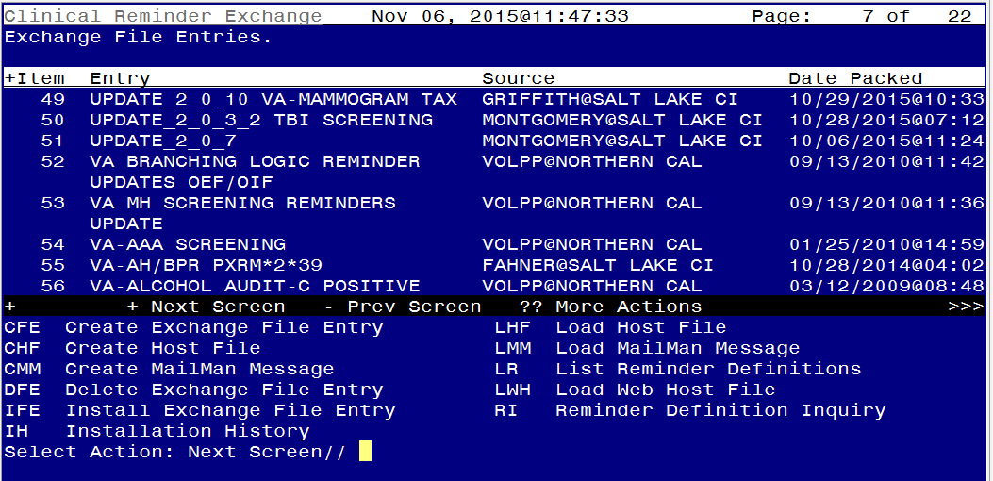

At the Select Action prompt, enter IFE for Install Exchange File Entry

Enter the number that corresponds with your entry titled UPDATE_2_0_2 (in this example it is entry 50, it will vary by site)

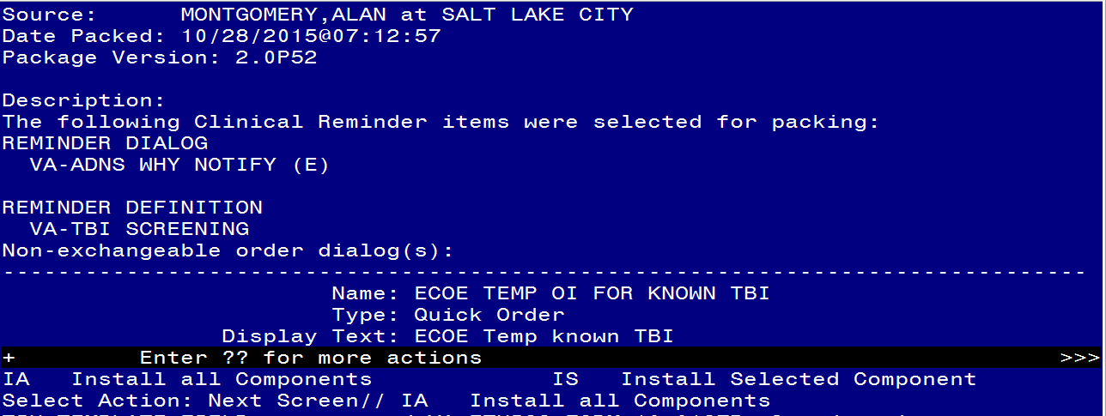

At the Select Action prompt, type IA for Install all components and hit enter.

Here is the detail on the installation including the prompts you could see during installation and how you should answer them:
TIU TEMPLATE FIELD entry named VA-ETHICS-FORM 10-0137B already exists
but the packed component is different, what do you want to do?

Select one of the following:

C Create a new entry by copying to a new name
O Overwrite the current entry
U Update
Q Quit the install
S Skip, do not install this entry

Enter response: O// verwrite the current entry
Are you sure you want to overwrite? N// YES
TIU TEMPLATE FIELD entry named VA-ETHICS-FORM 10-0137A already exists
but the packed component is different, what do you want to do?

Select one of the following:

C Create a new entry by copying to a new name
O Overwrite the current entry
U Update
Q Quit the install
S Skip, do not install this entry

Enter response: O// verwrite the current entry
Are you sure you want to overwrite? N// YES

TIU TEMPLATE FIELD entry named VA-ETHICS-LINK-HB-1004-02 already
exists and the packed component is identical, skipping.

TIU TEMPLATE FIELD entry named BLANK TEXT FIELD FOR DIALOGS already
exists and the packed component is identical, skipping.

TIU TEMPLATE FIELD entry named VA-TBI PMR POLYTRAUMA already exists
but the packed component is different, what do you want to do?

Select one of the following:

C Create a new entry by copying to a new name
O Overwrite the current entry
U Update
Q Quit the install
S Skip, do not install this entry

Enter response: O// verwrite the current entry
Are you sure you want to overwrite? N// YES
TIU TEMPLATE FIELD entry named VA-TBI POLYTRAUMA already exists and
the packed component is identical, skipping.

TIU TEMPLATE FIELD entry VA-TBI SCR/HIST RPT is NEW,
what do you want to do?

Select one of the following:

C Create a new entry by copying to a new name
I Install
Q Quit the install
S Skip, do not install this entry

Enter response: I// nstall

TIU TEMPLATE FIELD entry VA-TBI PRIOR SCREEN RESULTS is NEW,
what do you want to do?

Select one of the following:

C Create a new entry by copying to a new name
I Install
Q Quit the install
S Skip, do not install this entry

Enter response: I// nstall

TIU TEMPLATE FIELD entry VA-VAMC LOCATIONS is NEW,
what do you want to do?

Select one of the following:

C Create a new entry by copying to a new name
I Install
Q Quit the install
S Skip, do not install this entry

Enter response: I// nstall
TIU TEMPLATE FIELD entry named VA-DATE COMBO Y/M already exists and
the packed component is identical, skipping.

HEALTH FACTORS entry named TBI-SECTIONS already exists and the packed
component is identical, skipping.

HEALTH FACTORS entry named TBI-SCREENED PREVIOUSLY already exists and
the packed component is identical, skipping.

REMINDER TERM entry named VA-TBI-PT REFUSAL already exists but the packed component is different, what do you want to do?

Select one of the following:

C Create a new entry by copying to a new name
M Merge findings
O Overwrite the current entry
U Update
Q Quit the install
S Skip, do not install this entry

Enter response: O// Merge findings

HEALTH FACTORS entry named TBI SOURCE already exists and the packed
component is identical, skipping.

HEALTH FACTORS entry named TBI-OTHER INJURY TO HEAD already exists
and the packed component is identical, skipping.

HEALTH FACTORS entry named TBI-BLOW TO HEAD already exists and the
packed component is identical, skipping.

HEALTH FACTORS entry named TBI RESULTS already exists and the packed
component is identical, skipping.

HEALTH FACTORS entry named TBI-HEAD INJURY already exists and the
packed component is identical, skipping.

HEALTH FACTORS entry named TBI-CONCUSSION already exists and the
packed component is identical, skipping.

HEALTH FACTORS entry named TBI SYMPTOMS already exists and the packed
component is identical, skipping.
HEALTH FACTORS entry named TBI CURRENT SYMPTOMS already exists and
the packed component is identical, skipping.

HEALTH FACTORS entry named TBI-CURRENT SLEEP PROBLEM already exists
and the packed component is identical, skipping.

HEALTH FACTORS entry named TBI-REFERRALS already exists and the
packed component is identical, skipping.

HEALTH FACTORS entry named TBI-REFERRAL DECLINED already exists and
the packed component is identical, skipping.

HEALTH FACTORS entry named TBI-REFERRAL SENT already exists and the
packed component is identical, skipping.

HEALTH FACTORS entry named TBI-SECTION IV - YES already exists and
the packed component is identical, skipping.

HEALTH FACTORS entry named TBI-SECTION IV - NO already exists and the
packed component is identical, skipping.

HEALTH FACTORS entry named TBI-CURRENT HEADACHES already exists and
the packed component is identical, skipping.

HEALTH FACTORS entry named TBI-CURRENT IRRITABILITY already exists
and the packed component is identical, skipping.

HEALTH FACTORS entry named TBI-CURRENT VISUAL PROBLEMS already exists
and the packed component is identical, skipping.

HEALTH FACTORS entry named TBI-CURRENT DIZZINESS already exists and
the packed component is identical, skipping.

HEALTH FACTORS entry named TBI-CURRENT MEMORY PROBLEMS already exists
and the packed component is identical, skipping.

HEALTH FACTORS entry named TBI-SECTION III - YES already exists and
the packed component is identical, skipping.

HEALTH FACTORS entry named TBI-SECTION III - NO already exists and
the packed component is identical, skipping.

HEALTH FACTORS entry named TBI-VISUAL PROBLEMS already exists and the
packed component is identical, skipping.

HEALTH FACTORS entry named TBI-IRRITABILITY already exists and the
packed component is identical, skipping.

HEALTH FACTORS entry named TBI-MEMORY PROBLEMS already exists and the
packed component is identical, skipping.

HEALTH FACTORS entry named TBI-DIZZINESS already exists and the
packed component is identical, skipping.

HEALTH FACTORS entry named TBI-HEADACHES already exists and the
packed component is identical, skipping.

HEALTH FACTORS entry named TBI-SECTION II - YES already exists and
the packed component is identical, skipping.

HEALTH FACTORS entry named TBI-SECTION II - NO already exists and the
packed component is identical, skipping.

HEALTH FACTORS entry named TBI-UNCONSCIOUS already exists and the
packed component is identical, skipping.

HEALTH FACTORS entry named TBI-NO MEMORY OF INJURY already exists and
the packed component is identical, skipping.

HEALTH FACTORS entry named TBI-DAZED/CONFUSED already exists and the
packed component is identical, skipping.

HEALTH FACTORS entry named TBI-SECTION I - YES already exists and the
packed component is identical, skipping.

HEALTH FACTORS entry named TBI-SECTION I - NO already exists and the
packed component is identical, skipping.

HEALTH FACTORS entry named TBI-BLAST already exists and the packed
component is identical, skipping.

HEALTH FACTORS entry named TBI-FALL already exists and the packed
component is identical, skipping.

HEALTH FACTORS entry named TBI-VEHICULAR already exists and the
packed component is identical, skipping.

HEALTH FACTORS entry named TBI-FRAGMENT/BULLET already exists and the
packed component is identical, skipping.

HEALTH FACTORS entry named TBI-PREVIOUS TBI DX already exists and the
packed component is identical, skipping.

HEALTH FACTORS entry named IRAQ/AFGHANISTAN already exists and the
packed component is identical, skipping.

HEALTH FACTORS entry named OTHER OEF SERVICE already exists and the
packed component is identical, skipping.

HEALTH FACTORS entry named UZBEKISTAN SERVICE already exists and the
packed component is identical, skipping.

HEALTH FACTORS entry named TAJIKISTAN SERVICE already exists and the
packed component is identical, skipping.

HEALTH FACTORS entry named PHILIPPINES SERVICE already exists and the
packed component is identical, skipping.

HEALTH FACTORS entry named PAKISTAN SERVICE already exists and the
packed component is identical, skipping.

HEALTH FACTORS entry named KYRGYZSTAN SERVICE already exists and the
packed component is identical, skipping.

HEALTH FACTORS entry named GEORGIA SERVICE already exists and the
packed component is identical, skipping.

HEALTH FACTORS entry named AFGHANISTAN SERVICE already exists and the
packed component is identical, skipping.

HEALTH FACTORS entry named IRAQ/AFGHAN SERVICE already exists and the
packed component is identical, skipping.

HEALTH FACTORS entry named OTHER OIF SERVICE already exists and the
packed component is identical, skipping.

HEALTH FACTORS entry named TURKEY SERVICE already exists and the
packed component is identical, skipping.

HEALTH FACTORS entry named SAUDI ARABIA SERVICE already exists and
the packed component is identical, skipping.

HEALTH FACTORS entry named KUWAIT SERVICE already exists and the
packed component is identical, skipping.

HEALTH FACTORS entry named IRAQ SERVICE already exists and the packed
component is identical, skipping.

HEALTH FACTORS entry named NO IRAQ/AFGHAN SERVICE already exists and
the packed component is identical, skipping.

REMINDER SPONSOR entry named Office of Patient Care Services already
exists and the packed component is identical, skipping.

REMINDER SPONSOR entry named Office of Public Health and
Environmental Hazards already exists and the packed component is
identical, skipping.

REMINDER SPONSOR entry named Office of Quality & Performance already
exists and the packed component is identical, skipping.

REMINDER TERM entry named VA-IRAQ/AFGHAN SERVICE REGISTRATION already
exists but the packed component is different, what do you want to do?

Select one of the following:

C Create a new entry by copying to a new name
M Merge findings
O Overwrite the current entry
U Update
Q Quit the install
S Skip, do not install this entry

Enter response: O// Merge findings

REMINDER TERM entry named VA-IRAQ/AFGHAN SERVICE already exists and
the packed component is identical, skipping.
REMINDER TERM entry named VA-COMBAT VET already exists but the packed
component is different, what do you want to do?

Select one of the following:

C Create a new entry by copying to a new name
M Merge findings
O Overwrite the current entry
U Update
Q Quit the install
S Skip, do not install this entry

Enter response: O// Merge findings
REMINDER TERM entry named VA-TBI-PT REFUSAL already exists and the
packed component is identical, skipping.

REMINDER TERM entry named VA-TBI-PREVIOUS TBI DX already exists and
the packed component is identical, skipping.

REMINDER TERM entry named VA-IRAQ/AFGHAN SERVICE NO already exists
and the packed component is identical, skipping.
REMINDER TERM entry named VA-ACTIVE DUTY already exists but the
packed component is different, what do you want to do?

Select one of the following:

C Create a new entry by copying to a new name
M Merge findings
O Overwrite the current entry
U Update
Q Quit the install
S Skip, do not install this entry

Enter response: O// Merge findings
REMINDER TERM entry named VA-IRAQ/AFGHAN PERIOD OF SERVICE already
exists and the packed component is identical, skipping.

REMINDER DEFINITION entry named VA-TBI SCREENING already exists but
the packed component is different, what do you want to do?

Select one of the following:

C Create a new entry by copying to a new name
O Overwrite the current entry
U Update
Q Quit the install
S Skip, do not install this entry

Enter response: O// verwrite the current entry
Are you sure you want to overwrite? N// y YES

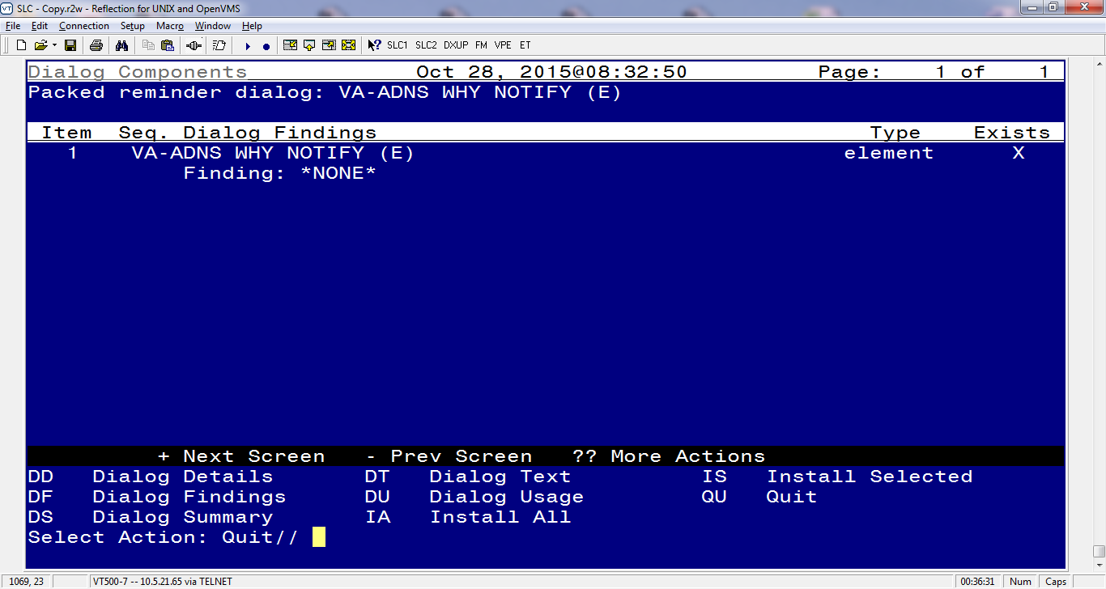

When the first part of the installation is complete, you will be returned to this screen. At the Select Action prompt, type Q to quit this portion and move on to the next step in the install.
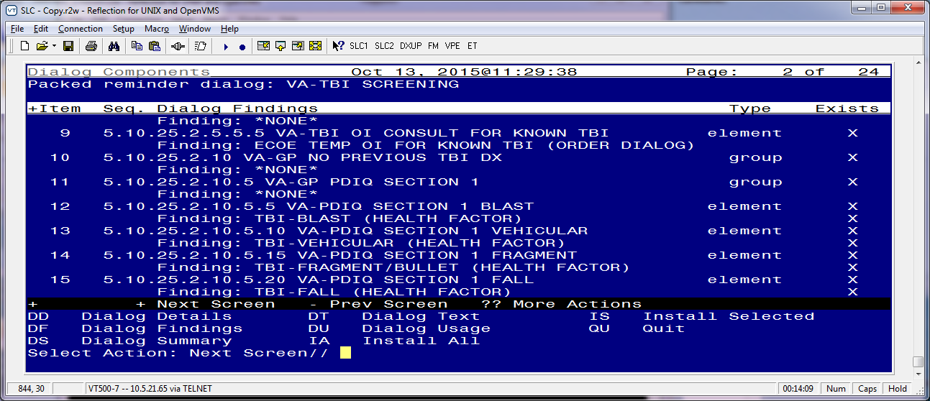
You will then be returned to this screen. At the Select Action prompt, type IA to install the dialog.

Install reminder dialog and all components with no further changes: Y// ES
REMINDER DIALOG entry named VA-OEF/OIF SERVICE REGISTRATION already
exists and the packed component is identical, skipping.

REMINDER DIALOG entry named VA-TEXT BLANK LINE WITH TEMPLATE FIELD
already exists and the packed component is identical, skipping.

REMINDER DIALOG entry named VA-TBI SCREEN REFUSAL already exists and
the packed component is identical, skipping.

REMINDER DIALOG entry named VA-PDIQ REFERRAL DECLINED already exists
and the packed component is identical, skipping.

FINDING entry Q.ECOE TEMP OI FOR POLYTRAUMA CONSULT does not exist.

Select one of the following:

D Delete
P Replace with an existing entry
Q Quit the install

Enter response: p Replace with an existing entry
Select ORDER DIALOG NAME: GMRCOR CONSULT - PUT YOUR CONSULT ORDER HERE
REMINDER DIALOG entry named VA-PDIQ SECTION 4 NEGATIVE already exists
and the packed component is identical, skipping.

REMINDER DIALOG entry named VA-GP PDIQ SECTION 4 RESULTS already
exists and the packed component is identical, skipping.

REMINDER DIALOG entry named VA-PDIQ SECTION 4 SLEEP PROBLEMS already
exists and the packed component is identical, skipping.

REMINDER DIALOG entry named VA-PDIQ SECTION 4 HEADACHES already exists
and the packed component is identical, skipping.

REMINDER DIALOG entry named VA-PDIQ SECTION 4 IRRITABILITY already
exists and the packed component is identical, skipping.

REMINDER DIALOG entry named VA-PDIQ SECTION 4 VISUAL PROBLEMS already
exists and the packed component is identical, skipping.

REMINDER DIALOG entry named VA-PDIQ SECTION 4 BALANCE PROBLEMS
already exists and the packed component is identical, skipping.

REMINDER DIALOG entry named VA-PDIQ SECTION 4 MEMORY PROBLEMS already
exists and the packed component is identical, skipping.

REMINDER DIALOG entry named VA-GP PDIQ SECTION 4 already exists and
the packed component is identical, skipping.

REMINDER DIALOG entry named VA-GP PDIQ SECTION 3 POSITIVE already
exists and the packed component is identical, skipping.

REMINDER DIALOG entry named VA-PDIQ TEXT SCREEN COMPLETED already
exists and the packed component is identical, skipping.

REMINDER DIALOG entry named VA-GP PDIQ SECTION 3 NEGATIVE already
exists and the packed component is identical, skipping.

REMINDER DIALOG entry named VA-GP PDIQ SECTION 3 RESULTS already
exists and the packed component is identical, skipping.

REMINDER DIALOG entry named VA-PDIQ SECTION 3 SLEEP PROBLEMS already
exists and the packed component is identical, skipping.

REMINDER DIALOG entry named VA-PDIQ SECTION 3 HEADACHES already exists
and the packed component is identical, skipping.

REMINDER DIALOG entry named VA-PDIQ SECTION 3 IRRITABILITY already
exists and the packed component is identical, skipping.

REMINDER DIALOG entry named VA-PDIQ SECTION 3 VISUAL PROBLEMS already
exists and the packed component is identical, skipping.

REMINDER DIALOG entry named VA-PDIQ SECTION 3 DIZZINESS already exists
and the packed component is identical, skipping.

REMINDER DIALOG entry named VA-PDIQ SECTION 3 MEMORY PROBLEMS already
exists and the packed component is identical, skipping.

REMINDER DIALOG entry named VA-GP PDIQ SECTION 3 already exists and
the packed component is identical, skipping.

REMINDER DIALOG entry named VA-GP PDIQ SECTION 2 POSITIVE already
exists and the packed component is identical, skipping.

REMINDER DIALOG entry named VA-PDIQ TEXT SCREEN COMPLETED already
exists and the packed component is identical, skipping.

REMINDER DIALOG entry named VA-GP PDIQ SECTION 2 NEGATIVE already
exists and the packed component is identical, skipping.

REMINDER DIALOG entry named VA-GP PDIQ SECTION 2 RESULTS already
exists and the packed component is identical, skipping.

REMINDER DIALOG entry named VA-PDIQ SECTION 2 HEAD INJURY already
exists and the packed component is identical, skipping.

REMINDER DIALOG entry named VA-PDIQ SECTION 2 CONCUSSION already
exists and the packed component is identical, skipping.

REMINDER DIALOG entry named VA-PDIQ SECTION 2 NOT REMEMBERING already
exists and the packed component is identical, skipping.

REMINDER DIALOG entry named VA-PDIQ SECTION 2 DAZED already exists
and the packed component is identical, skipping.

REMINDER DIALOG entry named VA-PDIQ SECTION 2 UNCONSCIOUS already
exists and the packed component is identical, skipping.

REMINDER DIALOG entry named VA-GP PDIQ SECTION 2 already exists and
the packed component is identical, skipping.

REMINDER DIALOG entry named VA-GP PDIQ SECTION 1 POSITIVE already
exists and the packed component is identical, skipping.

REMINDER DIALOG entry named VA-PDIQ TEXT SCREEN COMPLETED already
exists and the packed component is identical, skipping.

REMINDER DIALOG entry named VA-GP PDIQ SECTION 1 NEGATIVE already
exists and the packed component is identical, skipping.

REMINDER DIALOG entry named VA-GP PDIQ SECTION 1 RESULTS already
exists and the packed component is identical, skipping.

REMINDER DIALOG entry named VA-PDIQ SECTION 1 OTHER INJURY TO HEAD
already exists and the packed component is identical, skipping.

REMINDER DIALOG entry named VA-PDIQ SECTION 1 BLOW TO HEAD already
exists and the packed component is identical, skipping.

REMINDER DIALOG entry named VA-PDIQ SECTION 1 FALL already exists and
the packed component is identical, skipping.

REMINDER DIALOG entry named VA-PDIQ SECTION 1 FRAGMENT already exists
and the packed component is identical, skipping.

REMINDER DIALOG entry named VA-PDIQ SECTION 1 VEHICULAR already exists
and the packed component is identical, skipping.

REMINDER DIALOG entry named VA-PDIQ SECTION 1 BLAST already exists
and the packed component is identical, skipping.

REMINDER DIALOG entry named VA-GP NO PREVIOUS TBI DX already exists
and the packed component is identical, skipping.

FINDING entry Q.ECOE TEMP OI FOR KNOWN TBI does not exist.

Select one of the following:

D Delete
P Replace with an existing entry
Q Quit the install

Enter response: p Replace with an existing entry
Select ORDER DIALOG NAME: GMRCOR CONSULT - PUT YOUR CONSULT ORDER HERE
REMINDER DIALOG entry named VA-TBI TEXT PREVIOUS DX NO SCREEN already
exists and the packed component is identical, skipping.

REMINDER DIALOG entry named VA-GP PREVIOUS TBI DIAGNOSIS already
exists and the packed component is identical, skipping.

REMINDER DIALOG entry named VA-GP POST DEPLOYMENT INJURY
QUESTIONNAIRE already exists and the packed component is identical,
skipping.

REMINDER DIALOG entry named PXRM COMMENT already exists and the
packed component is identical, skipping.

REMINDER DIALOG entry named VA-HF OEF OTHER already exists and the
packed component is identical, skipping.

REMINDER DIALOG entry named VA-HF OEF UZBEKISTAN already exists and
the packed component is identical, skipping.

REMINDER DIALOG entry named VA-HF OEF TAJIKISTAN already exists and
the packed component is identical, skipping.

REMINDER DIALOG entry named VA-HF OEF THE PHILIPPINES already exists
and the packed component is identical, skipping.

REMINDER DIALOG entry named VA-HF OEF PAKISTAN already exists and the
packed component is identical, skipping.

REMINDER DIALOG entry named VA-HF OEF KYRGYZSTAN already exists and
the packed component is identical, skipping.

REMINDER DIALOG entry named VA-HF OEF GEORGIA already exists and the
packed component is identical, skipping.

REMINDER DIALOG entry named VA-HF OEF AFGHANISTAN already exists and
the packed component is identical, skipping.

REMINDER DIALOG entry named VA-GP OEF LOCATIONS already exists and
the packed component is identical, skipping.

REMINDER DIALOG entry named VA-GP OIF COMBAT SERVICE YES OEF (2)
already exists and the packed component is identical, skipping.

REMINDER DIALOG entry named PXRM COMMENT already exists and the
packed component is identical, skipping.

REMINDER DIALOG entry named VA-HF OIF OTHER already exists and the
packed component is identical, skipping.

REMINDER DIALOG entry named VA-HF OIF TURKEY already exists and the
packed component is identical, skipping.

REMINDER DIALOG entry named VA-HF OIF SAUDI ARABIA already exists and
the packed component is identical, skipping.

REMINDER DIALOG entry named VA-HF OIF KUWAIT already exists and the
packed component is identical, skipping.

REMINDER DIALOG entry named VA-HF OIF IRAQ already exists and the
packed component is identical, skipping.

REMINDER DIALOG entry named VA-GP OIF LOCATIONS already exists and
the packed component is identical, skipping.

REMINDER DIALOG entry named VA-GP OIF COMBAT SERVICE YES OIF (2)
already exists and the packed component is identical, skipping.

REMINDER DIALOG entry named VA-GP OIF COMBAT SERVICE NO already exists
and the packed component is identical, skipping.

REMINDER DIALOG entry named VA-GP OIF COMBAT SERVICE YES CLOSED
already exists and the packed component is identical, skipping.

REMINDER DIALOG entry named VA-GP TBI OEF/OIF REENTER INFO already
exists and the packed component is identical, skipping.

REMINDER DIALOG entry named VA-GP TBI OEF/OIF SERVICE already exists
and the packed component is identical, skipping.

REMINDER DIALOG entry named VA-TEXT BLANK LINE WITH TEMPLATE FIELD
already exists and the packed component is identical, skipping.

REMINDER DIALOG entry named VA-TEXT BLANK LINE WITH TEMPLATE FIELD
already exists and the packed component is identical, skipping.

REMINDER DIALOG entry named VA-TEXT BLANK LINE WITH TEMPLATE FIELD
already exists and the packed component is identical, skipping.

REMINDER DIALOG entry named VA-GP PRIOR TBI SCREEN RESULTS already
exists and the packed component is identical, skipping.

REMINDER DIALOG entry named VA-GP PRIOR TBI SCREEN COMPLETED
ELSEWHERE already exists and the packed component is identical,
skipping.

REMINDER DIALOG entry named VA-GP TBI SCREEN VSSC LINK already exists
and the packed component is identical, skipping.

REMINDER DIALOG entry named VA-GP TBI SCREEN DONE AT OTHER VA already
exists and the packed component is identical, skipping.

REMINDER DIALOG entry named VA-TBI SCREEN REFUSAL already exists and
the packed component is identical, skipping.

REMINDER DIALOG entry named VA-PDIQ REFERRAL DECLINED already exists
and the packed component is identical, skipping.

FINDING entry Q.ECOE TEMP OI FOR POLYTRAUMA CONSULT does not exist.

Select one of the following:

D Delete
P Replace with an existing entry
Q Quit the install

Enter response: p Replace with an existing entry
Select ORDER DIALOG NAME: GMRCOR CONSULT - PUT YOUR CONSULT ORDER HERE
REMINDER DIALOG entry named VA-GP PDIQ SECTION 4 POSITIVE already
exists and the packed component is identical, skipping.

REMINDER DIALOG entry named VA-PDIQ SECTION 4 NEGATIVE already exists
and the packed component is identical, skipping.

REMINDER DIALOG entry named VA-GP PDIQ SECTION 4 RESULTS already
exists and the packed component is identical, skipping.

REMINDER DIALOG entry named VA-PDIQ SECTION 4 SLEEP PROBLEMS already
exists and the packed component is identical, skipping.

REMINDER DIALOG entry named VA-PDIQ SECTION 4 HEADACHES already exists
and the packed component is identical, skipping.

REMINDER DIALOG entry named VA-PDIQ SECTION 4 IRRITABILITY already
exists and the packed component is identical, skipping.

REMINDER DIALOG entry named VA-PDIQ SECTION 4 VISUAL PROBLEMS already
exists and the packed component is identical, skipping.

REMINDER DIALOG entry named VA-PDIQ SECTION 4 BALANCE PROBLEMS
already exists and the packed component is identical, skipping.

REMINDER DIALOG entry named VA-PDIQ SECTION 4 MEMORY PROBLEMS already
exists and the packed component is identical, skipping.

REMINDER DIALOG entry named VA-GP PDIQ SECTION 4 already exists and
the packed component is identical, skipping.

REMINDER DIALOG entry named VA-GP PDIQ SECTION 3 POSITIVE already
exists and the packed component is identical, skipping.

REMINDER DIALOG entry named VA-PDIQ TEXT SCREEN COMPLETED already
exists and the packed component is identical, skipping.

REMINDER DIALOG entry named VA-GP PDIQ SECTION 3 NEGATIVE already
exists and the packed component is identical, skipping.

REMINDER DIALOG entry named VA-GP PDIQ SECTION 3 RESULTS already
exists and the packed component is identical, skipping.

REMINDER DIALOG entry named VA-PDIQ SECTION 3 SLEEP PROBLEMS already
exists and the packed component is identical, skipping.

REMINDER DIALOG entry named VA-PDIQ SECTION 3 HEADACHES already exists
and the packed component is identical, skipping.

REMINDER DIALOG entry named VA-PDIQ SECTION 3 IRRITABILITY already
exists and the packed component is identical, skipping.

REMINDER DIALOG entry named VA-PDIQ SECTION 3 VISUAL PROBLEMS already
exists and the packed component is identical, skipping.

REMINDER DIALOG entry named VA-PDIQ SECTION 3 DIZZINESS already exists
and the packed component is identical, skipping.

REMINDER DIALOG entry named VA-PDIQ SECTION 3 MEMORY PROBLEMS already
exists and the packed component is identical, skipping.

REMINDER DIALOG entry named VA-GP PDIQ SECTION 3 already exists and
the packed component is identical, skipping.

REMINDER DIALOG entry named VA-GP PDIQ SECTION 2 POSITIVE already
exists and the packed component is identical, skipping.

REMINDER DIALOG entry named VA-PDIQ TEXT SCREEN COMPLETED already
exists and the packed component is identical, skipping.

REMINDER DIALOG entry named VA-GP PDIQ SECTION 2 NEGATIVE already
exists and the packed component is identical, skipping.

REMINDER DIALOG entry named VA-GP PDIQ SECTION 2 RESULTS already
exists and the packed component is identical, skipping.

REMINDER DIALOG entry named VA-PDIQ SECTION 2 HEAD INJURY already
exists and the packed component is identical, skipping.

REMINDER DIALOG entry named VA-PDIQ SECTION 2 CONCUSSION already
exists and the packed component is identical, skipping.

REMINDER DIALOG entry named VA-PDIQ SECTION 2 NOT REMEMBERING already
exists and the packed component is identical, skipping.

REMINDER DIALOG entry named VA-PDIQ SECTION 2 DAZED already exists
and the packed component is identical, skipping.

REMINDER DIALOG entry named VA-PDIQ SECTION 2 UNCONSCIOUS already
exists and the packed component is identical, skipping.

REMINDER DIALOG entry named VA-GP PDIQ SECTION 2 already exists and
the packed component is identical, skipping.

REMINDER DIALOG entry named VA-GP PDIQ SECTION 1 POSITIVE already
exists and the packed component is identical, skipping.

REMINDER DIALOG entry named VA-PDIQ TEXT SCREEN COMPLETED already
exists and the packed component is identical, skipping.

REMINDER DIALOG entry named VA-GP PDIQ SECTION 1 NEGATIVE already
exists and the packed component is identical, skipping.

REMINDER DIALOG entry named VA-GP PDIQ SECTION 1 RESULTS already
exists and the packed component is identical, skipping.

REMINDER DIALOG entry named VA-PDIQ SECTION 1 OTHER INJURY TO HEAD
already exists and the packed component is identical, skipping.

REMINDER DIALOG entry named VA-PDIQ SECTION 1 BLOW TO HEAD already
exists and the packed component is identical, skipping.

REMINDER DIALOG entry named VA-PDIQ SECTION 1 FALL already exists and
the packed component is identical, skipping.

REMINDER DIALOG entry named VA-PDIQ SECTION 1 FRAGMENT already exists
and the packed component is identical, skipping.

REMINDER DIALOG entry named VA-PDIQ SECTION 1 VEHICULAR already exists
and the packed component is identical, skipping.

REMINDER DIALOG entry named VA-PDIQ SECTION 1 BLAST already exists
and the packed component is identical, skipping.

REMINDER DIALOG entry named VA-GP PDIQ SECTION 1 already exists and
the packed component is identical, skipping.

REMINDER DIALOG entry named VA-GP NO PREVIOUS TBI DX already exists
and the packed component is identical, skipping.

FINDING entry Q.ECOE TEMP OI FOR KNOWN TBI does not exist.

Select one of the following:

D Delete
P Replace with an existing entry
Q Quit the install

Enter response: p Replace with an existing entry
Select ORDER DIALOG NAME: GMRCOR CONSULT - PUT YOUR CONSULT ORDER HERE
REMINDER DIALOG entry named VA-TBI TEXT PREVIOUS DX NO SCREEN already
exists and the packed component is identical, skipping.

REMINDER DIALOG entry named VA-GP PREVIOUS TBI DIAGNOSIS already
exists and the packed component is identical, skipping.

REMINDER DIALOG entry named VA-GP PREVIOUS TBI DX already exists and
the packed component is identical, skipping.

REMINDER DIALOG entry named VA-GP POST DEPLOYMENT INJURY
QUESTIONNAIRE already exists and the packed component is identical,
skipping.

REMINDER DIALOG entry named VA-GP TBI COMBAT SERVICE YES already
exists and the packed component is identical, skipping.

REMINDER DIALOG entry named VA-GP OIF COMBAT SERVICE NO already exists
and the packed component is identical, skipping.

REMINDER DIALOG entry named VA-TBI OIF/OEF COMBAT YES/NO already
exists and the packed component is identical, skipping.

REMINDER DIALOG entry named VA-TBI SCREENING already exists and the
packed component is identical, skipping.

When the installation is complete, you will be returned to this screen. At the Select Action prompt, type Q to quit.

Install Completed

Post Installation
- Review reminder definition VA-TBI Screening. Review the reminder terms to make sure they are the same as the pre-install version the only changes to the reminder definition should be to the description and to the websites.

Review finding item on the below elements:VA-TBI OI CONSULT FOR KNOWN TBI and VA-PDIQ POLYTRAUMA CONSULTELEMENT and compare to the value pre-installation. Update if needed.
- Open TBI reminder dialog and make sure changes identified in the introduction are visible.

